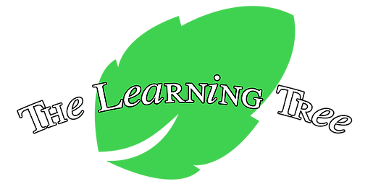
The Learning Tree, LLC
School Calendar
2024-2025

Monday, January 1 | School Closed, New Year's Day
Monday, January 15 | School Closed, Dr. Martin Luther King Day
Monday, February 19 | School Closed, President's Day
Friday, March 29 | School Closed, Good Friday
Monday, May 27 | School Closed, Memorial Day
Wednesday, June 19  July 4 and July 5 | School Closed, Juneteenth  School Closed, Fourth of July
Monday, September 2 | School Closed, Labor Day
Wednesday, November 27 | Closing at 3pm
Thursday, November 28 | School Closed, Thanksgiving
Friday, November 29 | School Closed, Thanksgiving
December 24-December 27  Tuesday, December 31 School Closed, New Year’s Eve | School Closed, Christmas Break
Wednesday, January 1 School Closed, New Year’s Day
School calendar subject to change

