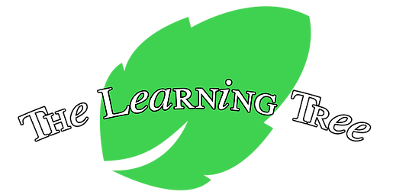
The Learning Tree, LLC
School Calendar
2022-2023

Friday, January 1 | School Closed, New Year's Day
Monday, January 17 | School Closed, Dr. Martin Luther King Day
Monday, February 21 | School Closed, President's Day
Friday, April 15 | School Closed, Good Friday
Monday, May 30 | School Closed, Memorial Day
Friday, June 17  Monday, July 4 | School Closed, Juneteenth (Observed)  School Closed, Fourth of July
Monday, September 5 | School Closed, Labor Day
Wednesday, November 23 | Closing at 3pm
Thursday, November 24 | School Closed, Thanksgiving
Friday, November 25 | School Closed, Thanksgiving
Thursday, December 22 | Closing at 3pm
Friday, December 23 | School Closed, Christmas Eve
Monday, December 26  Thursday, December 29 | School Closed, Christmas (Observed)  Closing at 3pm
Friday, December 30 | School Closed, New Year's Eve (Observed)

School calendar subject to change

